If managers claim that negotiations start from scratch, tell them The Supreme Court DISAGREES

BARGAINING DOES NOT START FROM SCRATCH

With union representation, employees have a true voice. Once employees choose a union, their employer cannot make any changes to wages, benefits, or other terms of employment without bargaining with the employees’ union. U.S. Supreme Court – NLRB v. Katz, 369 U.S. 736 (1962).

Therefore, employer statements to employees during an organizing campaign that bargaining will “start from zero” or “from scratch” or “with a blank sheet” violate federal law because they threaten employees with the loss of existing benefits. National Labor Relations Board – Conley Trucking, 349 NLRB 308 (2007).
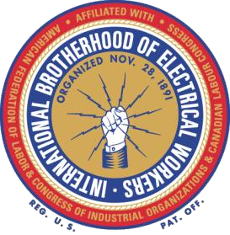
Bargaining doesn’t start from scratch – it starts from the status quo, with employees finally having a true voice to demand improvements.

INTERNATIONAL BROTHERHOOD OF ELECTRICAL WORKERS
®

AFL
-
CIO

The only way to protect your wages and benefits from the whims of management is to vote “Union
Yes.”

Without union representation, management can make changes to employees’ wages, benefits, or other terms of employment without employees having any say.
- What is your wage next Year?
- How about the following Year?
- How much will your Health Care cost?
- Will you have Health Care?
- Will you have a Retirement?
- How about Health Care after you Retire?
Don’t believe us? Contact your local NLRB office and ask if Bargaining starts from scratch 404-331-2896 or contact us at 601-590-0698

